ZD,
REPORT OF JOINT INVESTIGATION VISIT BY NOSDRA, RIVERS STATE MINISTRY OF ENVIRONMENT AND COMMUNITY AT MGBEDE 8Ss WELL HEAD @ MGBEDE COMMUNITY IN OGBA/EGBEMA/NDONI LGA OF RIVERS STATE.
INTRODUCTION
Acting on your directives on NAOC request dated 11th of April 2016, a Joint Investigation Visit (JIV) was conducted at the Mgbede 8Ss Well Head at Mgbede Community in Ogba/Egbema/Ndoni Local Government Area of Rivers State on the 11th of April, 2016 at about 14:30Hrs. The investigation was completed successfully on the same day. This report provides details.
INCIDENT PARTICULARS: 2016/NL/LAR/007/013
FACILITY AFFECTED: MGBEDE 8Ss WELL HEAD @ MGBEDE COMMUNITY IN OGBA/EGBEMA/NDONI LGA OF RIVERS STATE.
DATE OF SPILL: 03/04/2016
DATE OF INSPECTION: 11/04/2016
CAUSE OF SPILL: Third Party Interference (See Fig.1a & b)
QUANTITY OF CRUDE OIL SPILLED: ? (Facility set on Fire)
QUANTITY OF CRUDE RECOVERED: Nil
SPILL POINT COORDINATES: N 05^{O} 27’ 23.3’’
E 006^{O} 41’ 31.2”
NATURE OF IMPACT: Within ROW – Within the Well Head (See Fig.2a & b)
INVESTIGATION TEAM:
- Koms Abam NOSDRA
- Johnson Lucky NAOC (HSE)
- Chukwu Clinton NAOC (PAF)
- Georgewill Bibo T. NAOC (MTCE)
- Nkweke Chima NAOC (Production)
- Ajayi Sampson NAOC (ZIG INFO SURVEYOR)
- Ordu James RIVERS STATE MINISTRY OF ENVIRONMENT
- Onwuaddi Joseph MGBEDE COMMUNITY
OBSERVATIONS:
- The Spill occurred on land within the Mgbede Well Head 8Ss (See Fig. 1a & b).
- The Well Head was vandalized; the Flow line Needle Valve was cut-off (See Fig. 1b), all the bolts holding the Well Head destroyed (See Fig. 1a) and there was an attempt to inflict a Hacksaw cut on the Flow Line at 12 O’clock Position.
- The Facility was set on Fire and this affected the Well Head and the adjourning Environment, though within ROW (See Fig. 2a & b and 3a & b). As at the time of JIV, no Oil was found within the impacted Area, as everything has been consumed by fire. Below delineates:-
AREA IMPATED/AFFECTED By Fire Coordinates: N 05⁰ 27’ 23.3’’ E 006⁰ 41’ 31.2’’
N 05⁰ 27’ 23.3’’ E 006⁰ 41’ 31.4’’
N 05⁰ 27’ 23.8’’ E 006⁰ 41’ 31.6’’
N 05⁰ 27’ 23.6’’ E 006⁰ 41’ 31.1’’

ISSUES OF CONCERN - FEED BACK
- The Incident occurred on 3rd of April, 2016 and was reported the next day 4th of April, 2016 but JIV was only conducted on the 11th of April, 2016. Now six (6) days had passed-by before JIV was conducted and the Facility was set on fire; who could have set the Facility on fire? Could it have been the vandals or the operator?
- Again the letter NAOC sent to the Agency, received on the 13th of April, 2016 after the JIV indicates that a “Non-leak Incident” had occurred; how could a non-leaking point be consumed by fire?
- These two issues have raised great concern as to WHO actually set the Facility on fire.
RECOMMENDATIONS
- The Well Head should be repaired.
- NAOC should increase Surveillance in the Facility to guard against future occurrence.
- The Agency should impress it on NAOC that all necessary correspondences for a particular incidence should be made to the Agency before the date of JIV, so that all necessary background checks and preparations are done by concerned Staff before going for the investigation. This will help aid and improve our judgement on issues.
- Clean-up of the Impacted Area should be done, though it is within Operator’s ROW.

CONCLUSION
The JIV was successful. This report is subject to your steer and further directives.
Koms Abam
SES

_____________________________
DATE: 12th April, 2016

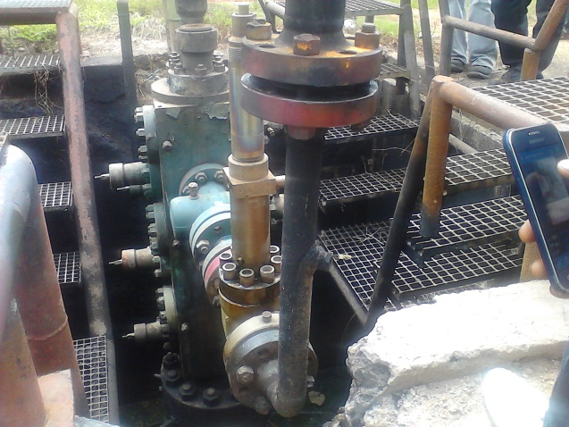 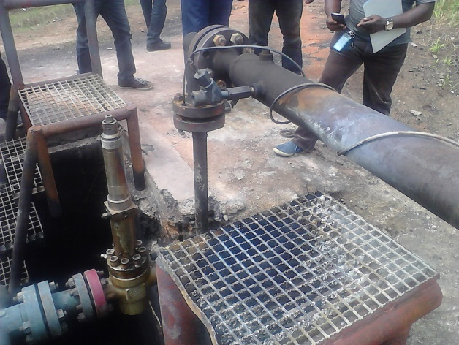 Fig. 1a Vandalized Well Head Fig.1b Flow Line Needle Valve removed
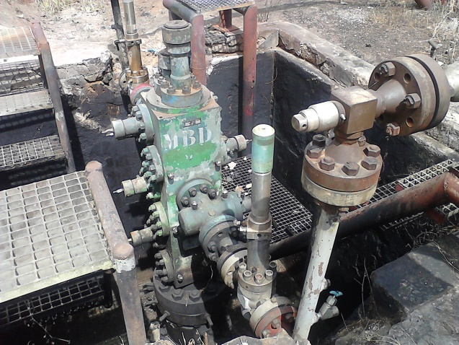 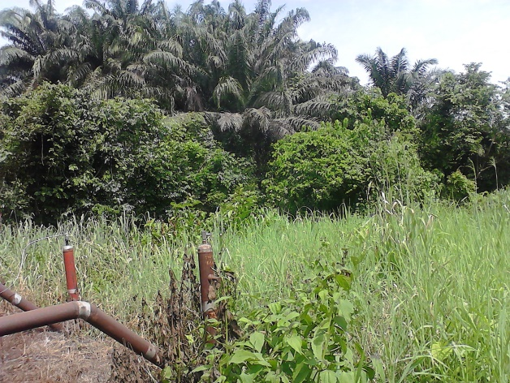 Fig. 2a Well Head burnt by Fire Fig. 2b
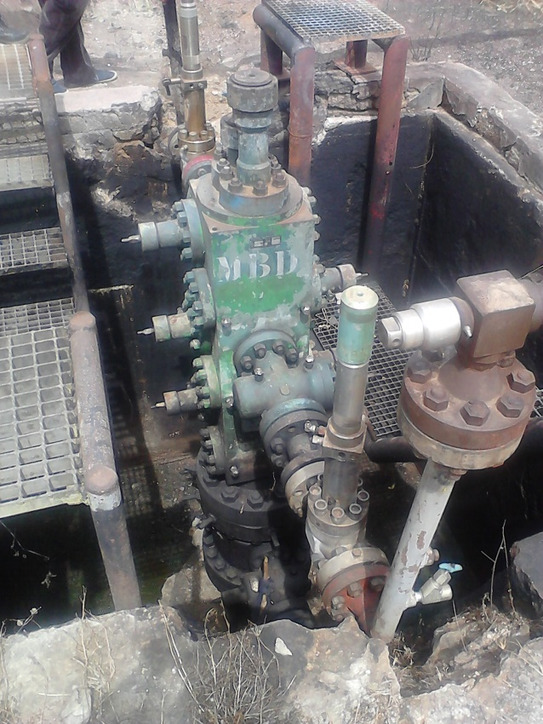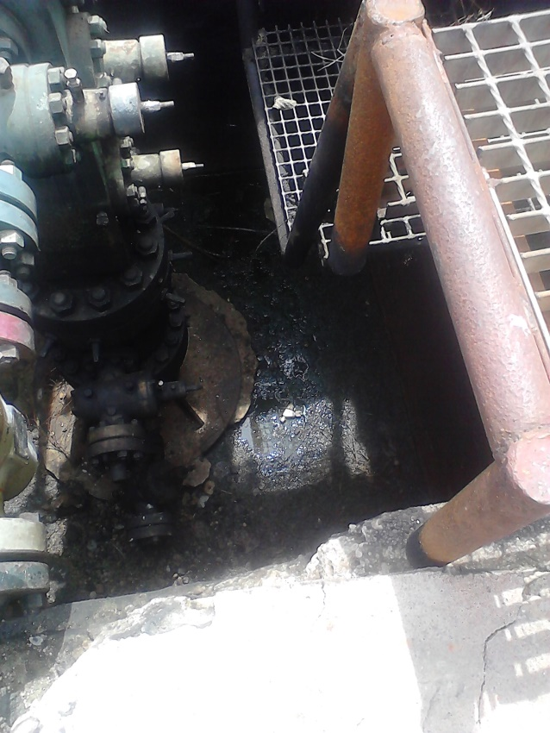
Fig. 3a Facility set on Fire Fig. 3b Facility set on Fire

